University Name- CMJ UNIVERSITY, MEGHALAYA
S.No. | Guidelines on Public Self- Disclosure by Higher Education Institutions |  | Remarks
a) | About HEI |  | Remarks
 |  | About Us: Overview | CMJ University was established in the year 2009 by an Act of Meghalaya State Legislature under the CMJ University, Act, 2009 (Act 4 of 2009) vide Notification No. LL (B) 42/09/80 dated 20th July, 2009. The CMJ University is notified by UGC (Ministry of HRD ,Government of India).New Delhi as state private University under section 2(f) and empowered to award Diploma, Bachelor, Master and Doctorate .  CMJ University is a legitimate university set up under the State Act, and the degrees offered by this university are recognized for Government jobs all over India.  Here we construct a situation of possibilities with an outlook of making new things happen that is supportive to any students who want to learn. At CMJ University we carry on an intellectual environment that could produce the next generation of leaders and thinkers. Our goal is to prepare the next generation to become conscientious citizen who can pound a difference in the society. We render world class learning experiences surrounding all the necessary disciplines requisite to establish oneself in society. Us believe fall back upon strong bonds between faculty and students, community building within the campus, develop critical thinking and ambitions etc.
 |  | Act and Statutes or MoA | CMJ Acts  CMJ Statutes
 |  | Institutional Development Plan | ---------------
 |  | Constituent Units/Affiliated Colleges, Affiliating University (in case of Colleges) Off- Campus/Off-shore campus/Learning Support Centres under ODL mode (wherever applicable) | STATE REGULAR PRIVATE UNIVERSITY  No Affiliated Colleges, Off- Campus/Off-shore campus/Learning Support Centres under ODL mode
 |  | Accreditation/Ranking status (NAAC, NBA NIRF) | NOT YET
 |  | Recognition/Approval (2(f), 12B, etc. as applicable) | 2(f)
 |  | Annual Reports | Annual Reports 2023-2024
 |  | Annual Account including Balance Sheet, Income and Expenditure Account, Receipts and Payments Account along with Audit Report | CMJ FOUNDATION
 |  | Sponsoring body details, if any | CMJ FOUNDATION
b) | Administration (Profiles with photograph and contact details)
 |  | Chancellor | 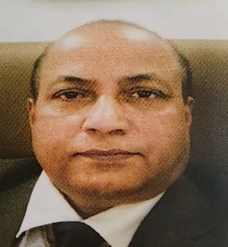  DR. CM JHA  Mob: 9810645532
 |  | Pro Chancellor | DR. GOVIND JHA  Mob: 9127055645
 |  | Vice- Chancellor |   DR. MK KAUSHAL  Mob: 8700538825
 |  | Pro- Vice- Chancellor (wherever applicable) | 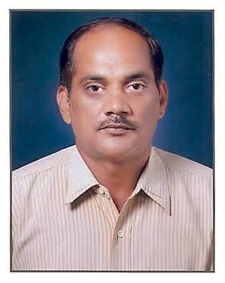  DR P K CHOUDHURY  Mob: 6003205262
 |  | Registrar | 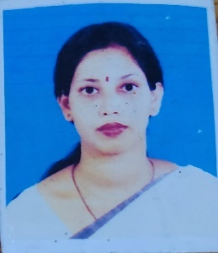  DR. M GOSWAMI  Mob: 9864012988
 |  | Finance Officer |   DR. RAJ KUMAR NIGLANI  Mob: 7838364801
 |  | Controller of Examination | 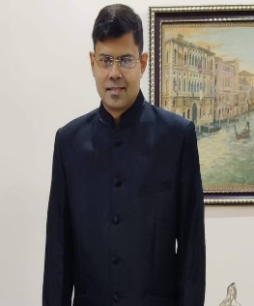  DR. SAUGAT BARUAH  Mob: 8787354774
 |  | Chief Vigilance Officer |   ALOK MISHRA  Mob:8099231480
 |  | Ombudsperson |   MRS. KABERI B BORTHAKUR  Mob:8876875294
 |  | Executive Council/Board of Governors by whatever name called, Board of Management, Academic Council, Board of Studies, Finance Committee- composition and members with particulars | Board of Governors  Board of Management  Academic Council
 |  | Internal Complaint Committee | GRIEVANCE CELL
 |  | Academic Leadership (Dean/HoD of Schools/Departments/Centres) | DEAN
c) | Academics
 |  | Details of Academic Programs | Academic Program
 |  | Academic Calendar | July – June Academic Year  January – December Calendar Year
 |  | Statutes/Ordinances pertaining to Academic/Examinations | Ordinances Governing admission to Programme leading to Bachelor’sDegree/Dual Degree/Master’s Degree; Under-  Graduate/Postgraduate Diplomas  Ordinances for PhD Programme
 |  | Schools/Departments/Centres | FACULTY
 |  | Schools/Departments/Centres faculty wise/staff details with photographs | Details of Faculty  Non-Teaching Staff
 |  | List of UGC-recognized ODL/Online programs, if any | NOT YET
 |  | Internal Quality Assurance Cell (IQAC) | YES
 |  | Library | YES
 |  | Academic collaboration | IN PROCESS
d) | Admission & Fee
 |  | Prospectus (including fee structure for various programs | CMJ Prospectus  Fee Structure
 |  | Admission process and guidelines | DIRECT ADMISSION
 |  | Fee refund policy | FEE IS REFUNDED WITHIN 7 DAYS OF ADMISSION IF CANCEL
e) | Research
 |  | Research and Development Cell (including research and Consultancy Projects, Foreign Collaboration Industry Collaborations) | RESEARCH CELL IS AVAILABLE
 |  | Incubation Centre/Start- ups /Entrepreneurship Cell | NIL
 |  | Central facilities | NIL
f) | Student Life
 |  | Sports facilities | YES
 |  | NCC/NSS - Details | NO
 |  | Hostel details (wherever applicable) | YES, BOYS AND GIRLS SEPARATE HOSTEL  300 BOYS CAPACITY  100 GIRLS CAPACITY
 |  | Placement Cell and its activities | NOT YET
 |  | Details of Student Grievance Redressal Committee (SGRC) and Ombudsperson | STUDENT REPRESENTATION and  PIO
 |  | Health Facilities | WITH WINDROP HOSPITAL
 |  | Internal Complaint Committee | NO
 |  | Anti-Ragging Cell | YES
 |  | Equal Opportunity Cell | NOT REQUIRED
 |  | Socio-Economically Disadvantage Groups Cell (SEDG) | NOT REQUIRED
 |  | Facilities for differently-abled (e.g., barrier-free environment) | YES
g) | Alumni
 |  | Alumni Association with details | NOT YET
h) | Information Corner
 |  | RTI: Details of Central Public Information Officer (CPIO) and Appellate Authority (wherever applicable) | PIO: Mrs Kaberi Borthakur  Appellate Authority- Registrar: Dr M Goswami
 |  | Circulars and Notices | DISPLAY IN THE UNIVERSITY BOARD & WEBSITE
 |  | Announcements | IN THE STUDENT GROUP AND WEBSITE
 |  | Newsletters | STOP AFTER COVID
 |  | News, Recent events & Achievements | PUBLISHED IN THE UNIVERSTIY WEBSITE
 |  | Job openings | YES
 |  | Reservation Roster (wherever applicable) | AS PER STATE NORMS
 |  | Study in India | ------
 |  | Admission procedure and facilities provided to International Students | POLICE VERIFICATION &  REGISTRATION IN FOREIGN STUDENTS  DEPARTMENT IN SP OFFICE, MEGHALAYA
i) | Picture Gallery |  | AVAILABLE IN WEBSITE
 |  | Details with Phone Number, Official Email ID and Address, Location map | CMJ UNIVERSITY  G.S Road, Jorabat, Ri-Bhoi District  Meghalaya-793101  Email: info@cmjumeghalaya.edu.in  Call: 0361-2897413/ 7002827562  https://maps.google.com/?cid=12195613397609929261&g_mp=CiVnb29nbGUubWFwcy5wbGFjZXMudjEuUGxhY2VzLkdldFBsYWNlEAEYASAB&hl=en-US&source=embed
 |  | Telephone Directory | AVAILABLE IN WEBSITE

